TITLe

Smith, J.1*, Parker, P.2, Cooper, S.3,

1: Institute/Department, University/Research institute/Museum, Address, Country

2: Institute/Department, University/Research institute/Museum, Address, Country

3: Institute/Department, University/Research institute/Museum, Address, Country

*E-mail: jones.smith@example.com

Text text text text text text text text text text text text text text text text text text text text text text text text text text text text text text text text text text text text text text text text text text text text text text text text text text text text text text text text text text text text text text text text text text text text text text text text text text text text text text text text text text text text text text text text text text text text text text text text text text text text text text (PRENDERGAST, 2000) text text text text text text text.

Text text text text text text text text text text text text text text text text text text text text text text text text text text text text text text text text text text text text text text text text text text text text text text text text text text text text text text text text text text text text text text text text text text text text text text text text text text text text text text text text text text text text text text text text text text text text text text text text text text text text.

Text text text text text text text text text text text text text text text text text text text text text text text text text text text text text text text text text text text text text text text text text text text text text text text text text text text text text text text text text text text text text text text text text text text text text text text text text text text text text text text text text text text text text text text text text text text text text text text text text text text (DUTKIEWICZ & MÜLLER, 2022) text text text text text text text text text text text text text text text text text text text text text text text text text text text text text text text text text text text text text text text text text text text text text text text text text text text text text text text text text text text text text text text text text text text text text text text text text text text text text text text text text text text text text text text text text text text text text text text text text text text text text text text text text text text text text text text text text text text text text text text text text text text text text text text text text text text text text text text text text text text text text text text text text text text text text text text text text text text text text text text text text text text text text text text text text (ALBERTI *et al.,* 2003 ) text text text text text text text text text text text text text text text text text text text text text text text text text text text text text text text text text text text text text text text text text text text text text text text text.

Text text text text text text text text text text text text text text text text text text text text text text text text text text text text text text text text text text text text text text text text text text text text text text text text text text text text text text text text text text text text text text text text text text text text text text text text text text text text text text text text text text text text text text text.

Text text text text text text text text text text text text text text text text text text text text text text text text text text text text text text text text text text text text text text text text text text text text text text text text text text text text text text text text text text text text text text text text text text text text text text text text text text text text text text text text text text text text text text text text text text text text text text text text text text text text text text text text text text text text text text text text text text text text text text text text text text text text text text text text text text text text text text text text text text text text text text text text text text text text text text text text text text text text text text text text text text text text text text text text text text text text text text text text text text text text text text text text text text text text text text text text text text text text text text text text text text text text text text text text text text text text text text text text text text text text text text text text text text text text text text text text text text text text text text text text text text text text text text text text text text text text text text text text text text text text text text text text text text text text (ALBERTI *et al.*, 2003 ) text text text text text text text text text text text text text text text text text text text text text text text text text text text text text text text text text text text text text text text text text text text text text text text text.

Text text text text text text text text text text text text text text text text text text text text text text text text text text text text text text text text text text text text text text text text text text text text text text text text text text text text text text text text text text text text text text text text text text text text text text text text text text text text text text text text text text text text text text text.

Text text text text text text text text text text text text text text text text text text text text text text text text text text text text text text text text text text text text text text text text text text text text text text text text text text text text text text text text text text text text text text text text text text text text text text text text text text text text text text text text text text text text text text text.

Text text text text text text text text text text text text text text text text text text text text text text text text text text text text text text text text text text text text text text text text text text text text text text text text text text text text text text text text text text text text text text text text text text text text text text text text text text text text text text text text text text text text text text text.

**References**

ALBERTI, A., FOIS, E., GAMBA, A. (2003): American Mineralogist, 88, 1–10.

DUTKIEWICZ, A., MÜLLER, R. D. (2022): Geology, 50, 710–715.

PRENDERGAST, M. D. (2000): Economic Geology, 95, 113–130.

Figure/Table 1.:

Figure/Table 2.:

Fig. 1.

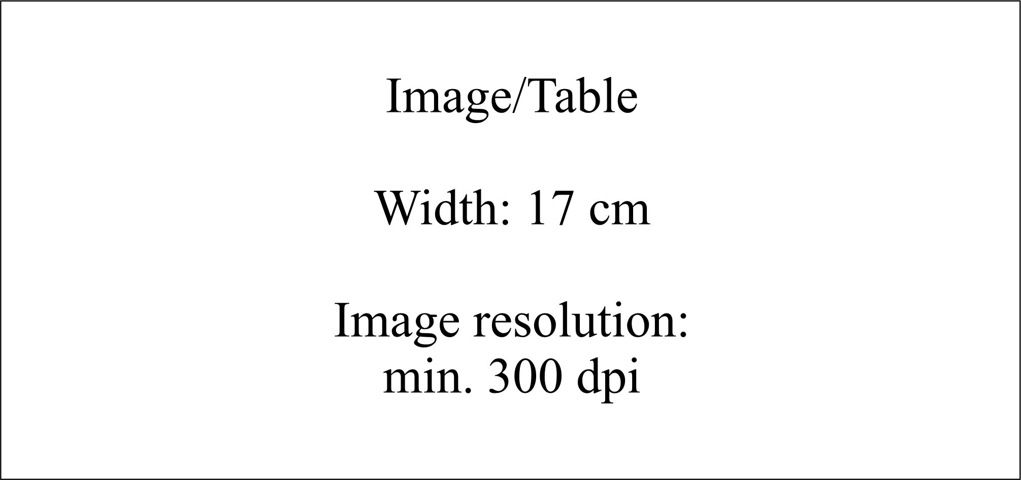

Fig. 2.

